Phishing Email Detection & Awareness System

CIN:FIT/MAY26/CS8278
SUBJECT:CYBER SECURITY LAB

Phishing Email Detection & Awareness System

Introduction
This project analyzes phishing, suspicious, and safe email samples. The objective is to identify phishing indicators, classify risks, and provide security awareness recommendations.

Objectives
- Identify phishing indicators
- Classify emails as Safe, Suspicious, or Phishing
- Assess risk levels
- Provide prevention guidelines

Email Sample 1
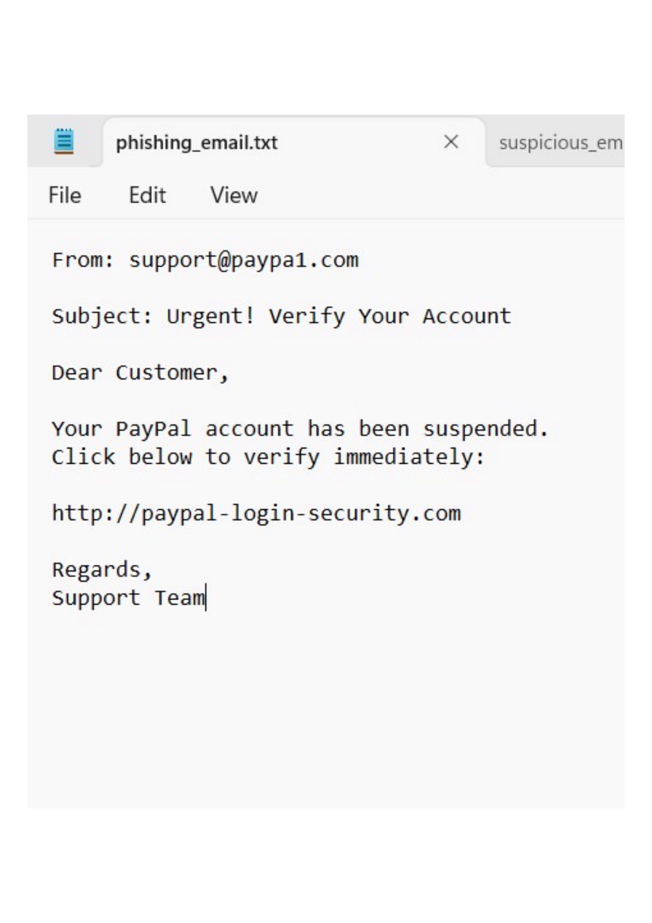
Classification: PHISHING
Risk Level: HIGH
Indicators: Spoofed sender domain (paypa1.com), urgency, suspicious URL, credential harvesting attempt.

Email Sample 2
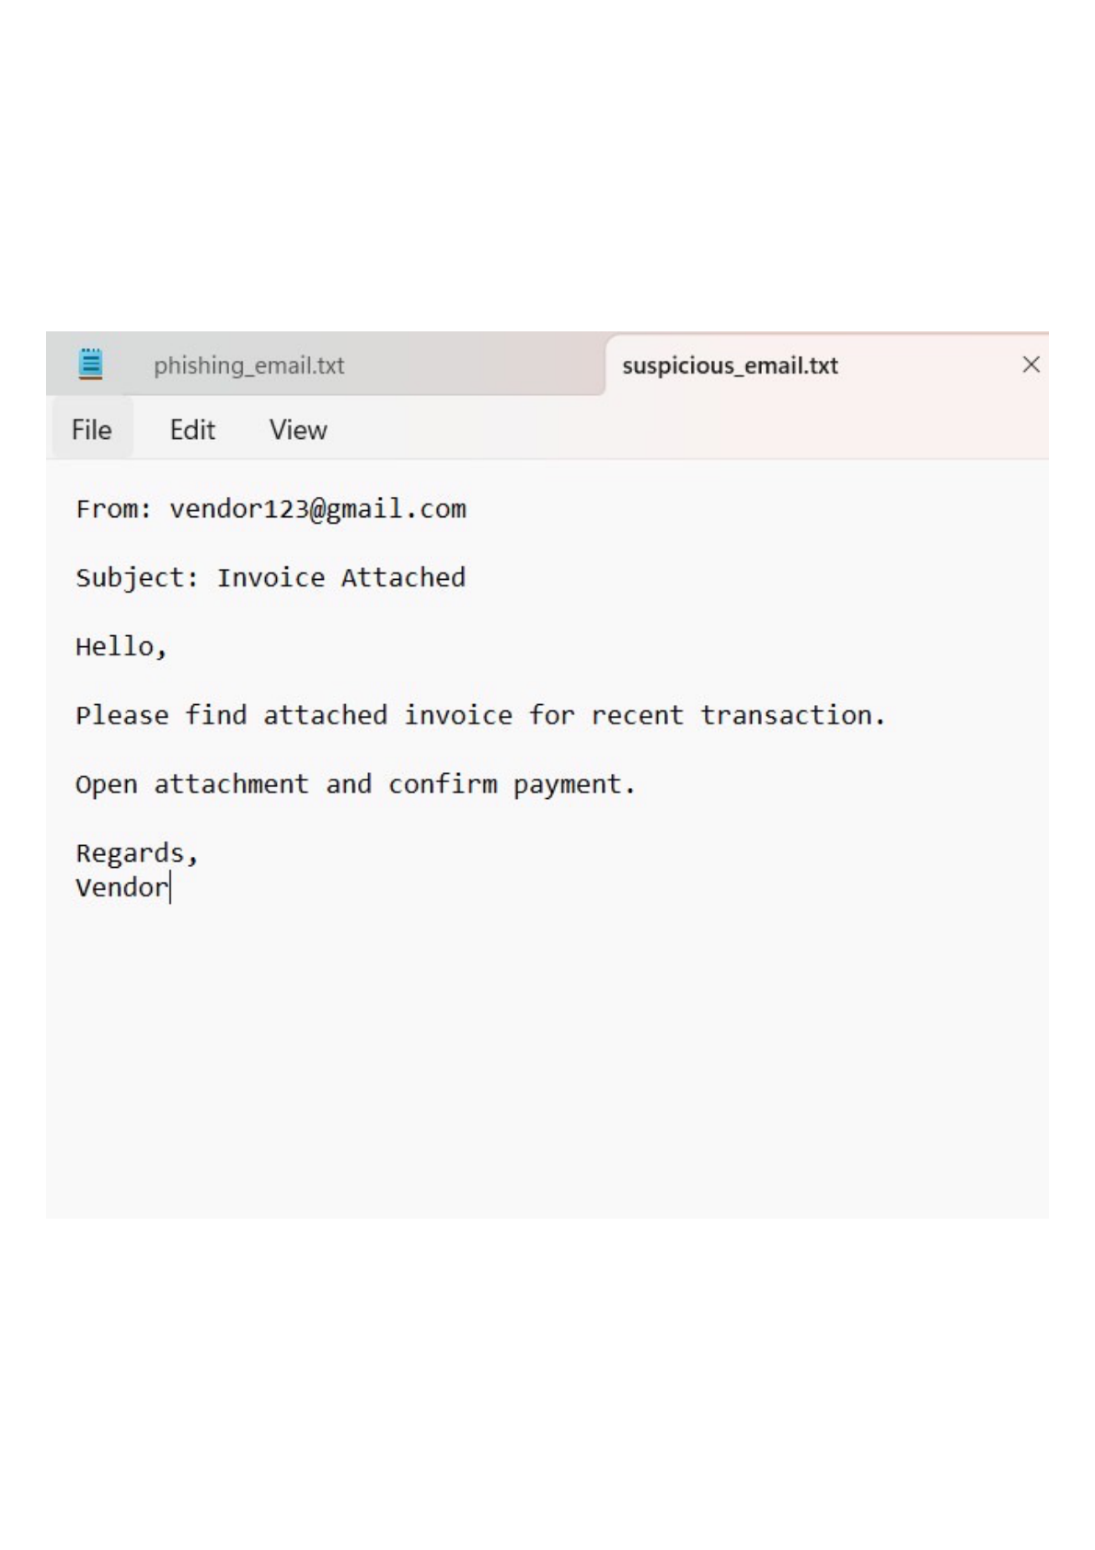
Classification: SUSPICIOUS
Risk Level: MEDIUM
Indicators: Unknown sender, unexpected invoice request, attachment-related social engineering.

Email Sample 3
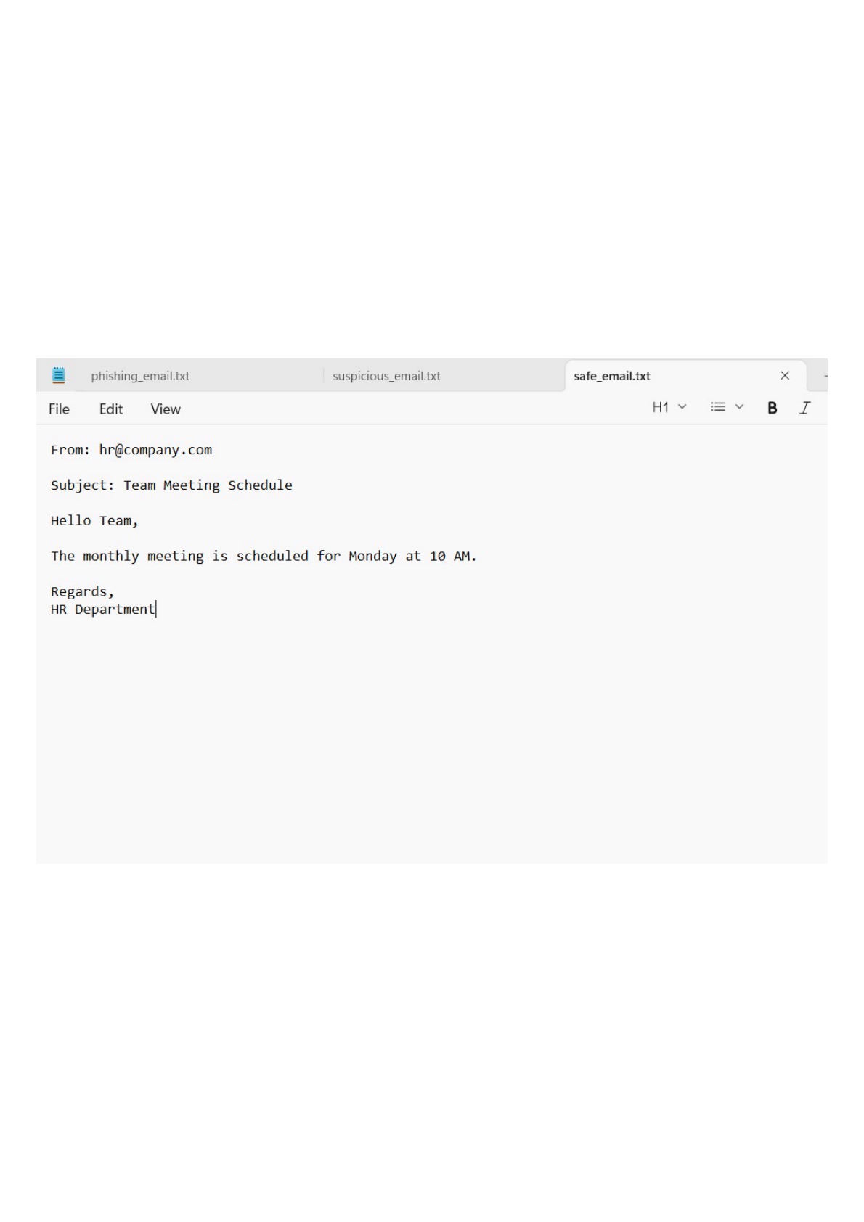
Classification: SAFE
Risk Level: LOW
Indicators: Legitimate sender domain, normal business communication, no suspicious links.

Risk Classification Summary
Email | Classification | Risk
Email 1 | Phishing | High
Email 2 | Suspicious | Medium
Email 3 | Safe | Low

Prevention Guidelines
1. Verify sender addresses.
2. Hover over links before clicking.
3. Do not open unexpected attachments.
4. Enable Multi-Factor Authentication (MFA).
5. Report suspicious emails to security teams.

Conclusion
The analysis demonstrates how phishing emails can be distinguished from legitimate communications using sender verification, link inspection, and content analysis.

